Using the link to the Holland Code, complete the quiz and paste the screen shot of your results below.

To Take the Online Quiz
Click this link or key the following link into your Internet browser to take the quiz online
http://www.roguecc.edu/Counseling/HollandCodes/test.asp

B. Screenshot your results.
After taking the quiz, do a screenshot of the results. Paste below:

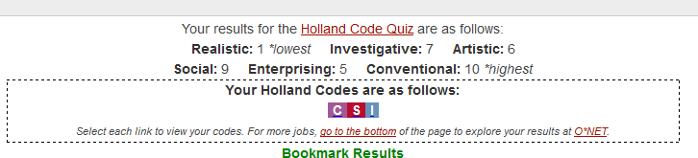

What is your highest code?
What is your lowest?
Are your career choices listed there? What other jobs are listed there that you might be interested in?
What patterns are you seeing in the types of personality inventories that we are doing?

