Middle school teacher
- What aspects of this occupation are suited to you? List them
- Working with children
- Training or teaching
- Presenting ideas and information in writing
- Organizing or supervising other people
- Planning how work is to be carried out
- Explaining ideas and information to people
- Considering the feelings, views or behavior of others

- Three facts from the job description section need to be written in your own words.
- Middle School teachers focus on one or two subjects
- They support their students
- The school district gives teachers the curriculum to teach but teachers have the freedom to choose how they teach the curriculum
3. Describe the working conditions in your own words.
- They teach in classrooms or offices.
- They have to meet deadlines and work with specific time constraints.
- They work shorter days then other careers but do a lot of work outside of the school day and school year.
4. Earnings – wages:
- What is the pay Level of Experience?
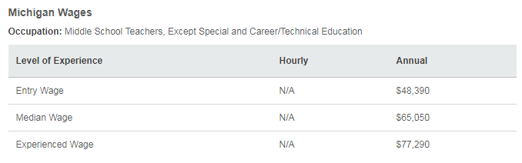
2.What is the national median income?
$65,050.00

3.What are some of the ways to earn extra pay?
- In some schools, teachers get extra pay to coach sports or supervise after-school activities. But in many cases, they don't get more money to help out after school. Some teachers also earn extra income by teaching summer school.
5. What is the Education & Training required for your job?
- You must have at least a bachelor's degree. It usually takes 4 years to earn this degree.
- You complete an approved teacher education program and certification is required.
- Teaching certification renewals require work experience and additional college classes.
- You learn educational theory and get the chance to teach in a real classroom.

2.What are other suggested qualifications?
- They must be excellent communicators.
- They are emotionally mature, enthusiastic, and show a sincere interest in young people.
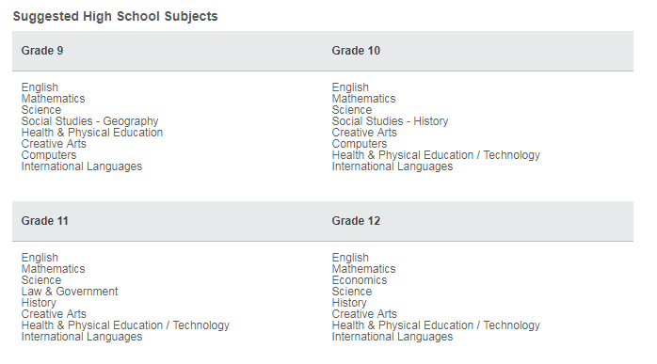
3.What are the suggested high school subjects?

6. Take snips of the 3 levels of the career path for the job.
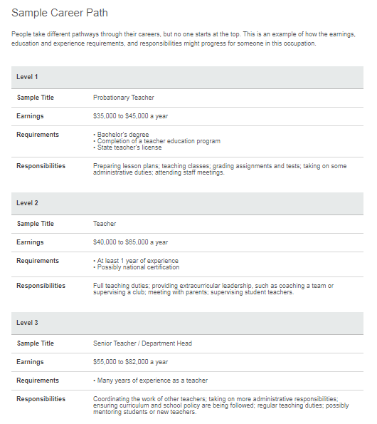

7. List 3 other occupations that you might be interested in that are related to this job.
- Librarian
- Professor
- Elementary School Teacher
8. Watch the video interviews for the career. List one thing that you learned from an interview.
- “If you want to be a teacher, you have to realize that the summers are there for a reason. During the winter months, you really work your butt off. It’s a lot of work.”

